

**GOOGLE DRIVE** | DOCS - SHEETS - SLIDES – FORMS | **83%**

* **Google Docs:** creating and formatting documents with real-time collaboration.
* **Google Sheets:** managing spreadsheets using knowledge of functions and formulas.
* **Google Slides:** creating and formatting appealing presentations, applying additional effects when needed.
* **Communication tools:** proficiency in using Gmail, Google Calendar, Google Meet, Google Chat, and more.

**SOCIAL MEDIA** | FACEBOOK – INSTAGRAM | **72%**

* **Facebook:** I increase page interaction on Facebook and increase followers.
* **Instagram:** I increase page interaction on Instagram, increase followers, and publish with the correct standards so that the post reaches those interested and because of my knowledge of Instagram algorithms.

**WEB DESIGN** | HTML - CSS - SASS - BOOTSTRAP | **92%**

* **HTML:** the standard markup language for Web pages.
* **CSS:** I format an HTML page with CSS to format web pages that care about the appearance and design of websites.
* **SASS:** CSS with superpowers. I use Sass, the most mature, stable, and powerful professional CSS extension language in the world. In some projects due to the many features it provides.
* **BOOTSTRAP:** I use bootstrap, the most popular HTML and CSS framework for developing responsive and mobile-first web projects... to save some time and speed up productivity.

**MS OFFICE** | WORD - EXCEL - POWERPOINT - OUTLOOK | **98%**

* **Microsoft Word:** Creating, formatting, and editing text documents.
* **Microsoft Excel skills:** Proficiency in data entry, formulas, sorting, filtering, etc.
* **Microsoft PowerPoint:** Preparing visually appealing, clean presentations.
* **Microsoft Outlook:** Managing emails and contacts, scheduling appointments, etc.

**Abdelrahman Hamed**

**WEB DESIGNER**

**Hire Me**

**Better Resume Experience**

**HAMED'S - AR**

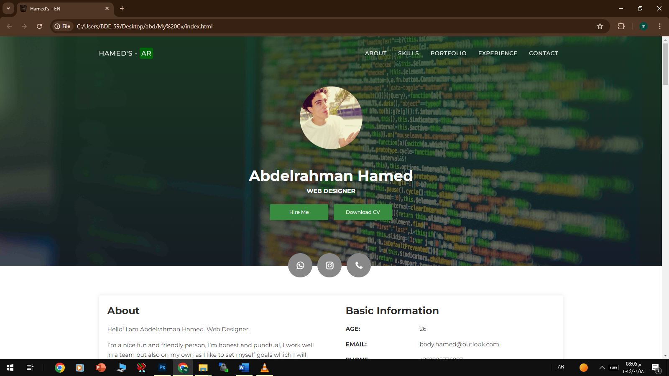

**About**

Hello! I am Abdelrahman Hamed. Web Designer.

I’m a nice fun and friendly person, I’m honest and punctual, I work well in a team but also on my own as I like to set myself goals which I will achieve, I have good listening and communication skills. I have a creative mind and am always up for new challenges. I am well organized and always plan ahead to make sure I manage my time well. [Learn More](https://wa.me/00201025736993)

**Basic Information**

AGE: 26

EMAIL: body.hamed@outlook.com

PHONE: +201025736993

ADDRESS: Cairo, Giza

LANGUAGE: [Arabic](rtl/rtl-cv.pdf), English

**Professional Skills**

**Other Computer Skills**

**1- Research the Web**

I can always search the Internet very professionally to solve a problem, get information, or even learn something new... whether it's from educational sites, articles, or through a YouTube lesson. I can rely on online research to create a project without having the experience to create it.

**2- Identify Opportunities**

I connect with people who share the same passions and interests as me. Maybe we can collaborate on a project together or simply learn from each other.

**3- Practice Regularly**

Practice is key. I enhance my knowledge, and I'm not afraid to try different tools to expand my experience. As a development, I am now learning a new programming language, Python.

**4- Sign Up for Courses**

I look for platforms that allow users to grow their knowledge. The most popular ones are Coursera, Udemy, and Codecademy, where I can find many online courses to grow your skills. I can also check out Microsoft's technical courses, or simply browse tutorials on YouTube.

[](https://abdelrahman202.github.io/yousry/)[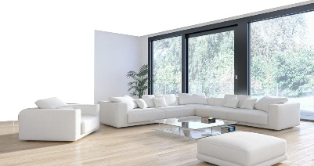](https://abdelrahman202.github.io/vieweypt/)[](https://abdelrahman202.github.io/MDAR/)[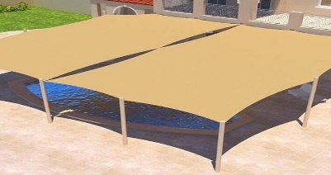](https://abdelrahman202.github.io/geda/)

**Some Of My Web Design Work**

Abdelrahman Hamed © Hamed's

**Social Media**

* **I ran a giveaway on Facebook that received 76,481 views, 3,300 likes, 460 comments, and 150 shares.**
* **I increased my Instagram followers to 70,000 real followers in two months and without ads**

**MS Office**

* **Used MS Word’s tracking and commenting to collaborate on reports with 30 cross-functional team members.**
* **Wrote Excel formulas to add conditional formatting to budgeting spreadsheets.**

**Work Experience**

**Web Design**

**I worked as a freelancer Web designer, especially on 'Khamsat micro services' and 'Mostaqel' for 7 years, and I sold nearly 2,000 services, and one of my most famous services is :  
Designed and maintained company website while tracking 1,500 monthly visitors**

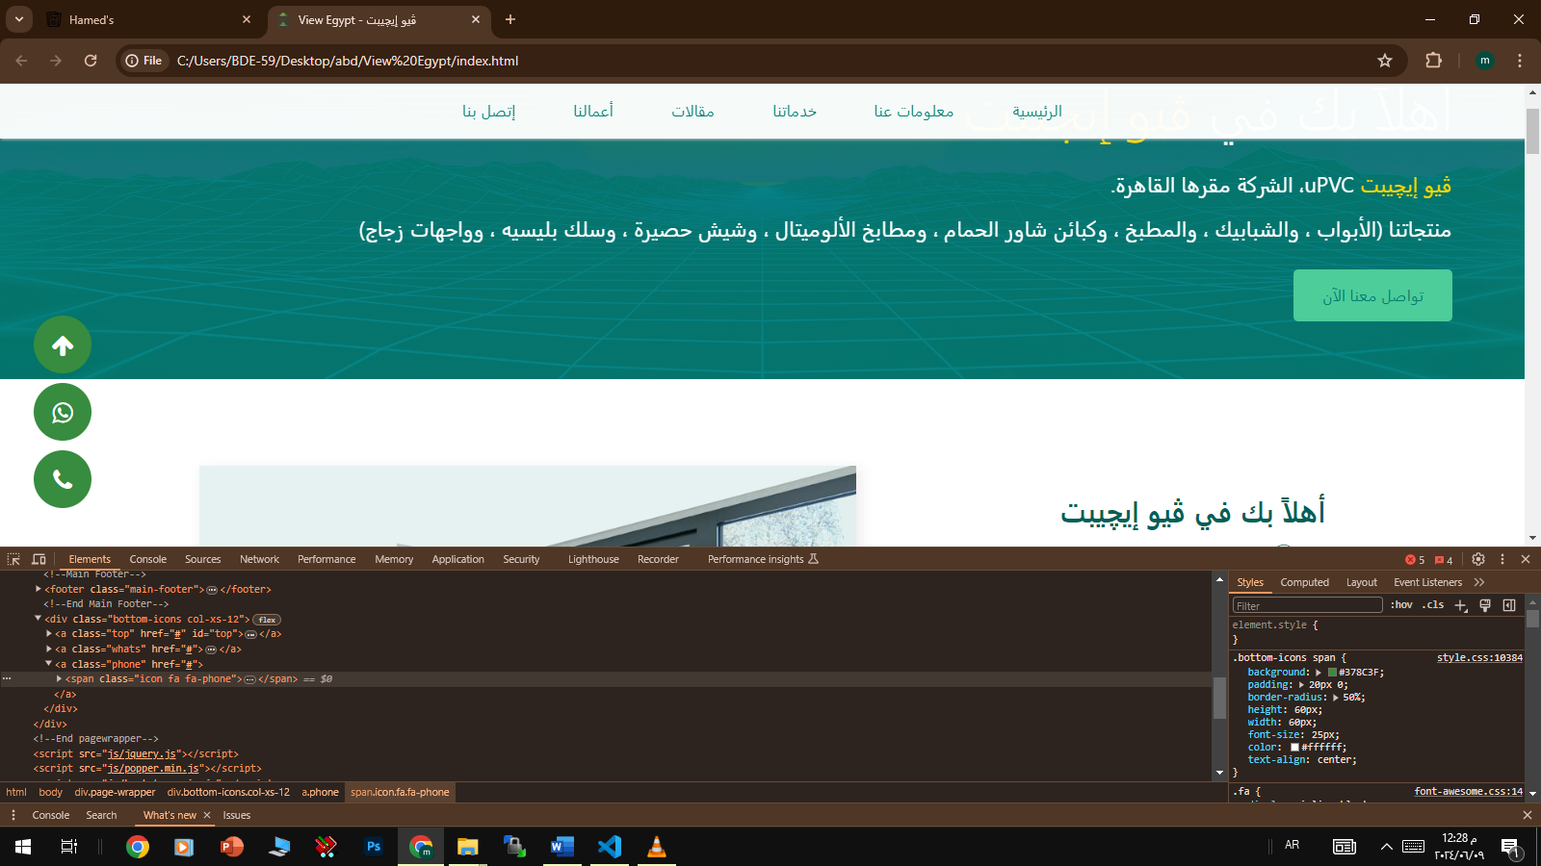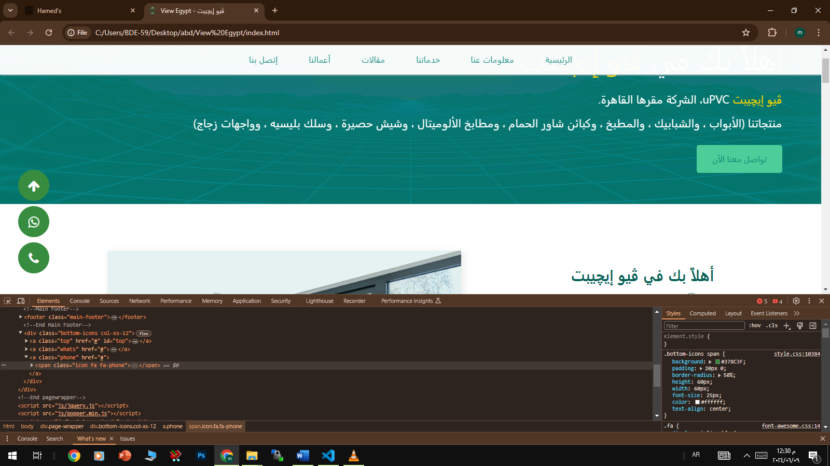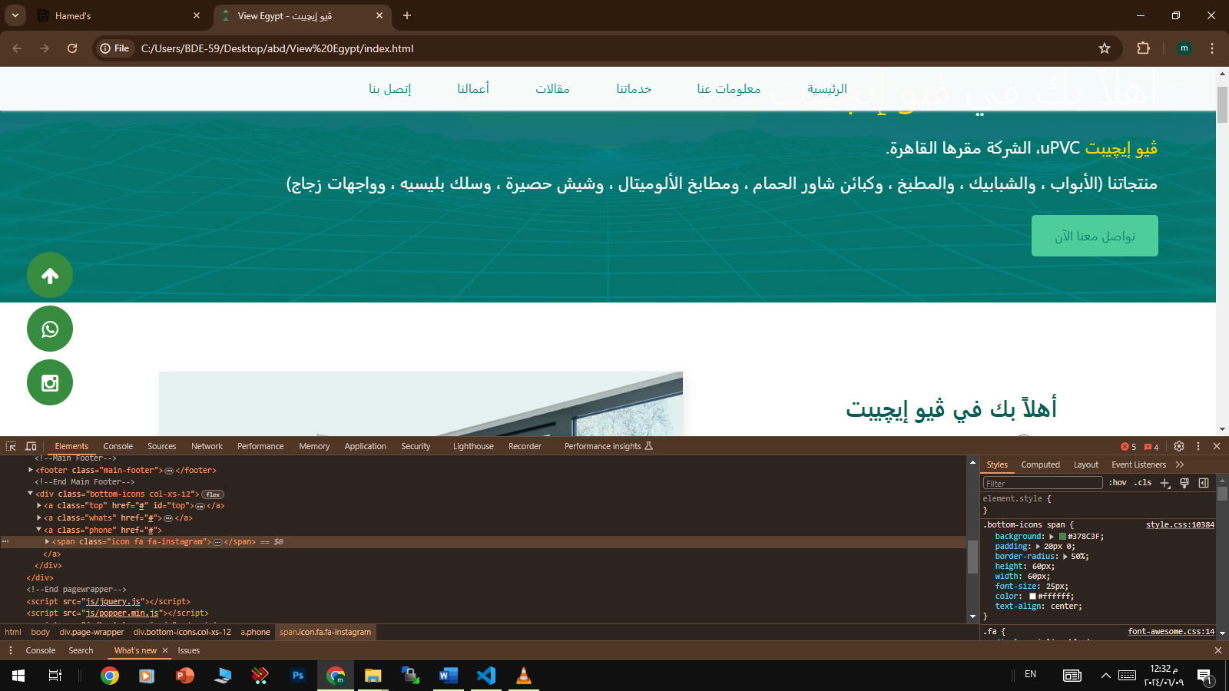

**Mdar Alsaa For Cleaning**

**Awnings and canopies in Jeddah**

**View Egypt uPVC**

**Personal website**